FRC Coding Cheat Sheet

Method Creation

Methods are used to run multiple lines of code in one. They also allow us to make otherwise unreadable code more organized and readable. These allow for a return type and parameters.

This is an example of a method without a return type, so we use void. It does have a parameter of power, which is its own variable that only this method can see.
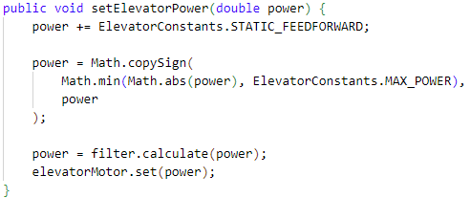
This is an example of a method that has no parameters but does have a return type. Note the Boolean in the method declaration and the keyword return inside of the block of code.

Subsystem Creation

Subsystems are used to store all the logic and information about a part on the robot. A subsystem would be a drivetrain, elevator, shooter, intake, etc. These subsystems can be as simple as just creating a motor and setting the run power or as complicated as interpreting a pose on the field to perform an action.

To create one, start the same way we would create any other java class. These will have getters and setters, a class method, and variables. The only differences are how it interacts with CommandScheduler. Subsystems are declared similar to below
To get started, we have to create the entry point for the subsystem, the class method. This will be called when we go to create the subsystem in RobotContainer.java. Class methods as a reminder, are created by using the public modifier, leaving the return type blank, and giving the method the same name as the class. So, for this Subsystem, the class method will look like this,
Subsystems also contain a periodic method, similar to the ones found in the Robot.java class. These will loop every 20ms that CommandScheduler is running. The one below is set up to run methods that pull PID values from the dashboard to allow for easier tuning, put information out to the dashboard for easier debugging when we inevitably run into issues, and updates a handshaking variable.
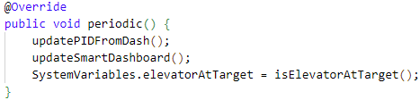

Hardware Configuration

Now that the subsystem has been created, we are ready to add things to it. The main device that will need to be set up is the motor(s). This section will also look at DigitalInputs and AnalogInputs.

The motors we will set up run off of the TalonFX motor controller. Each of these devices will have an associated CAN ID and a CANBUS where that ID is located on. Each system should have a set of IDs associated with it to make this process and debugging at comps easier. The CANBUS can be one of two things, one being the bus located on the RoboRIO and the other coming out of an external device like a CANivore. The RoboRIO’s bus is declared with an empty string and any other bus can be assigned a name. This will be set up like the following.
Sensors are set up in a similar way, but each ID is in reference to a physical location on the RoboRIO. The difference between the two are how they communicate information, with Digital Devices communicating with a binary bit, with only two possible states, on or off. Analog Devices on the other hand communicate with based off of how much voltage is passed through the wire. This will communicate with a number instead of just on or off. An easier way to look at these is with an example. A beam break sensor shoots a laser out and on the other side of a system there is a receiver. The receiver is then plugged into the RIO’s digital port and will tell the RIO if the laser is present or not. This will be configured similar to this,
A different type of device is a distance sensor. This type of device will shoot out a laser, then the laser will bounce back to the device and will return a different value based off of how far away the surface it hit was. This would be plugged into an Analog port on the RIO and be configured like the following,
When setting up motors, what we did before is only the first step. We also need to set other parameters of the motor through what is called a ‘Configuration.’ While complicated systems could end up changing a lot of the motor’s parameters, we will only cover a few. TalonFX has a class that we will use and build off of, declared below.
The first few parameters we will adjust is what direction we want forward, or positive, to be. Since motors can be mounted in any way, this will need to be checked before running to prevent running the wrong way. Another parameter is the neutral mode, or what happens when you set power to 0. In brake mode, power is applied to stop almost on a dime. In coast, power is turned off and the mechanism will run until another force is applied. We can also set the max speed in each direction. This will be a value from -1 to 1 with 1 being 100 percent. This is all initialized below.
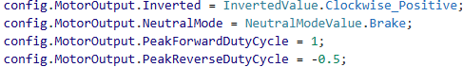
The final step in configuring the motor is actually applying them to the motor. This is simply done my getting the motors config and applying our config variable. This is shown below.

Hardware Operation

Now that the hardware is configured in the code, we need to create the code to use it. There are many ways to control a motor, this section will only go over a few. This will also go over how to get sensor information, although that is relatively intuitive.

The most basic way of operating a motor is to use DutyCycleOut. This runs the motor as a percent of max power as a value from -1 to 1. The two ways of setting this are below.
Another operation that is common with TalonFX motors are followers. These are used when mechanical needs more torque for a subsystem and runs two motors for one operation. The configuration would be the same for both motors (including direction, do not flip the direction in the config). Then, you will set the control mode to be a follower. The class method for Follower asks for the leader motor ID and whether the directions are switched. This is set up below.
The final way of operating a motor that I’m going to talk about here is using velocity. The main upside of this mode is consistency. Instead of being a percentage of max power, you are setting the target speed. This (mostly) eliminates the variable of battery power which could otherwise affect the speed. This mode does require you to tune the internal PID of your motor, which are found in the Slot0 configs.
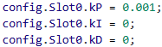
When setting it in velocity control, there are two ways that are mostly identical. The only difference is on the back end for the feedforward calculation. Both set the velocity in motor revolutions per second, so some math may be required to turn this into a usable value. Both ways are shown below.
When utilizing sensors, it’s even more important to use methods to get the information. This is because the sensors being used can change and are often utilized in many spots in the code. They also may be interpreted differently, like how a string potentiometer returns in positional ticks but may be changed in code to return inches. The first method we will look at is the most basic, just getting that value of a DigitalInput.
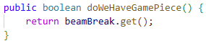
The next two are common functions with AnalogInputs. The first will be using a distance sensor in place of a beam break to make the subsystem easier to assemble. For this we need to check whether the value is below a certain point while still covering for the edge case where the distance sensor doesn’t see anything.
The second is using a device like a string pot that precisely measures a value. Since this will return as device ticks instead of whatever value we actually need. To cover for this, we will use a method to convert the value to a usable number. This would look like below.
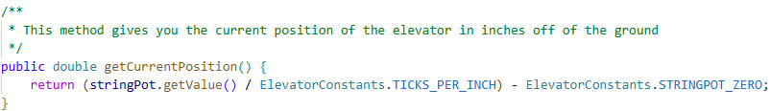
You may notice the comment above it. Above the declaration of any class or method, if you put a /** it will start a Javadoc comment. This will allow for text like what you see below to appear when you hover your cursor over a method or class. This allows you to add further clarification to methods than just the name of it.

Instance Creation

Now that one of the classes have been created, we need to learn how to utilize them inside of another class. This is called creating an instance of the class. These act the same way as a variable, but instead of having a type of int, double, string, or Boolean, they have a type that is the same as their class name. To call the constructor, you will use the keyword ‘new’ before calling that method. This will cause it to return the entire class. For the elevator class we have been building, this will look something like it does below.
Note the use of the modifier final here. This tells the code that this variable won’t be assigned a new value, something we can guarantee because the variable elevator already holds our entire class.

To use methods inside of our instance, we need to use our variable as a reference. This will be similar to doing ‘this.’ inside of a class method. After doing ‘variableName.’ We need to call our method. This will be done by typing out the name of the method and adding parentheses. If there are parameters, we will add values that will be assigned to those variables here. This could look something like this.
Side note, the words ‘power:’ and ‘maxPower’ are just the names of the parameters and are auto-populated by VSCode, you do NOT need to type these.

This process can also work for commands, (covered in the next section). These however, we won’t initialize as their own variables before using them. Just like how you can pass a number in as a parameter, we will pass a class in when it comes to commands. These will be set through controller inputs, so while a button is pressed, a command will run, or they can be set as a default command, so if no other command is calling that subsystem, it will run a certain command. These are set up below.

Command Creation

The purpose of a command-based structure is to have a different command for each different operation of the robot. Each command can be allocated to multiple subsystems at the same time, but best practice is to use one subsystem in each command. The setup for the file includes declaring the class as a command and creating the class method. One additional step is to tell the CommandScheduler what subsystems run in the command, so an additional line is required for that.
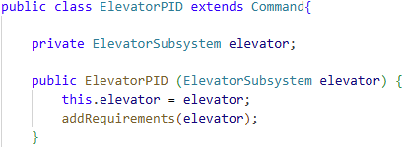
Each command is broken into four parts, the start, or initialize method. This runs once at the start of the command’s operation. Most often this is used to prevent a PID driven command from taking off when you don’t expect it to, so an addition of setting the current position to the target position could help this.
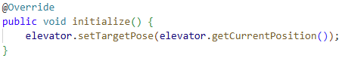
The next step is the loop, or the execute method. Just like in the Robot.java class and in subsystems, this method will loop every 20ms. This is where we will put the operational part of the code, so think for a PID command, this would run our PID method in the subsystem, or for a joystick command this will check the joystick position and set the power of the elevator based off of that. We also need to be aware of any other conditions that need to be met in order for a system to run. This process is called handshaking, and it is where two systems of the process communicate to each other. In FRC, the main way we will do this is with a Boolean bit being checked during operation. So, for our elevator, we need to check if the arm is clearing the elevator to run first before running. This will look like this.
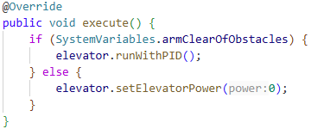
Next, we can create a condition to end the command. This isn’t necessary, since if the command is only being operated by a button the command would end when you let go regardless. But for situations like auto and buttons that operate a state machine, we will use the isFinished method. This method defaults to always returning a value of false, with the entire command ending when the method returns true. Even though when using a PID command, you will normally not have a end condition, for the means of explanation we will add one that will end the command when the elevator reaches its target position. Note: This command would fail with the previous steps creation of the initialize method causing the target pose to be the same as our current pose.
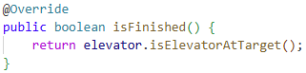
Finally, we will write what will happen when the command ends. This will happen with the end command that will take in a Boolean as a parameter. Here we will add logic to bring the system to a safe end state. So, in this command, we are going to set the power to zero, which with proper feedforwards in place, should hold the elevator in its current location.
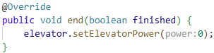
When creating commands like running a system off of a joystick or utilizes changing values that are not set up in the subsystem class or in a handshaking class, one tool you can use is called a Supplier. A Supplier allows for the running of a line of code to be a variable that will be run every time it is called. This can be used to check the most up-to-date information of what you are wanting to pass in.

PIDController Tuning

PID is the most powerful tool we use in FRC. What a PID allows us to do is to convert a target state into an output. This has many uses, like setting a target position of a positional subsystem like an elevator, arm, turret, hood, climber, or intake position. It also has uses with setting a target velocity, mainly used for flywheels. There are also weirder uses, like pure-pursuit drives and trajectory following (two main ways of autonomously driving to a point on a field). To understand these, we need to break it up into its components.

As you may have guessed, the three parts to a PID are called the P, the I, and the D (very clever I know). Each of these controls the output in a different way. To start, we will look at the most basic one, the P, or the proportional term. This part will find the error between the current state and the target state. So, if we want something to spin at 10 revolutions a second but it is currently stopped, the error would be 10. We then take the error and multiply it by our P constant, denoted as kP. If we set our kP to 0.05, in this example with the error of ten, our output would be 0.5.

The next part is our I, or the integral term. While to use a PID you don’t need to know calculus, the terms are still derived from calculus. An integral is known as the area under the curve. Think of a PID like a graph of error on the Y axis and time on the X axis. The integral is the area between where we are plotting our points and the x axis. The simplest way to think of this is the way it is coded, which is to take the current error and multiply it by the change in time. It then multiplies this by our kI constant and adds it up through every iteration.

The final part is the D, or the derivative term. This is another calculus term, this one being for the slope of that part of the graph. The way this is calculated in the code is taking the difference between the current and previous errors and dividing it by the difference between the current and previous time. Then, we take all of that and multiply it by our kD constant. Once we have all three components, we can add them up and return it as the output.

To create a PID, there are two main ways. One way is to use an instance of the PIDController class. This allows you to understand everything that goes into your subsystem code but may be slightly worse for performance. If the increased performance is deemed necessary, you may want to use the internal PID within the motor. This will cover how to setup both ways, but be careful to check documentation before using the internal PID.

The PIDController class is really simple to setup and only has a couple parts. Start by creating your instance.
Then, when going to use it, we need to know two things, the current and target states. You should have these built as getter methods inside of your subsystem. Then, call the calculate method of your instance and it will return whatever output you desire.
The other method is to use the motor. To set the PID coefficients, utilized the slot0 configs in the motor configuration.
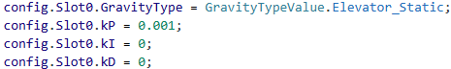
Then use either the velocity control if setting a target velocity or the positional control is setting a target position.

Now that we know what a PID is and have it built, it’s time to actually tune it. Start by setting kP to a really low number like 0.001 and the other two constants to 0. Then, gradually increase the kP until we see some oscillation on the graph. (Oscillation is what we call it when it goes back and forth over the setpoint). After that, reduce the kP slightly until oscillation stops. If the graph overshoots then get to its position, add in kD the same way you did kP until the overshoot stops. You may need to adjust the kP as you do this. If your graph looks good but it’s not quite making it to the setpoint, add in some kI. When you increase the kI, you will need to decrease the kP. After that is done, you should have a well-tuned machine.

Other Tools

Rotation2d is a class that holds rotational information. It is the go-to when interpreting angles on a robot since it automatically converts between radians and degrees. Most times called in a static way, like doing Rotation2d.fromDegrees() instead of creating an instance.

Pose2d is a class that holds positional information of the robot. This class has two doubles for x and y position and a Rotation2d for robot orientation. Used for positions on field, position of robot, limelight interpretation, and target positions for drive to pose commands.

Transform2d is a class that modifies the Pose2d class. This tool allows you to use the angle from the pose and does all the trig for determining a new pose from distance back and distance left or right values for you.

Units class is used to convert values from one unit to another. Accessed in the same static way as the Rotation2d class.

Math class is used to do complex math functions, like exponentials. Also accessed in a static way. Most common uses are for doing trig functions, which will always return a radian value instead of a degree value. Use either the Rotation2d class or the Unit class to convert after using.

SlewRateLimiter is a class that will prevent mechanisms from slipping. This could be an elevator that goes too quick and causes the gears to strip out or a drivetrain starting up too quick and the wheels free spinning on the carpet without the robot going anywhere. Both of these situations would be a good use of a SlewRateLimiter. How it works is it sets a max acceleration, which is defined as the change of velocity over a change in time. This will prevent the target velocity of the motor from exceeding a certain amount.

